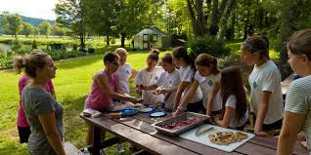  - FArm to Table Cooking Camp  Bring your young chef’s epicurean enthusiasm back to the source of the ingredients: land, soil, seeds, animals, plants and more. Campers will explore how to grow and cook a farm-fresh meal from the ground up using ingredients that are in season and grown on Glade Road Farm. After getting their hands dirty, kids will wash up and commence cooking. Nothing tastes better than a meal that is freshly harvested out of the ground! Parents are welcome to a Friday meal enjoying the culinary education.  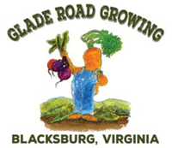 | Ages 6-13  July 22- 26 2019  9 a.m. to 3 p.m.  Develop Social Skills and Expand your Child’s Palate  A Blissful and Yummy Week will be had by all  Reserve a Seat at the Table  $255  To Register Contact  Scarlett Williams  scarlettwilliamslpc.com  (540)818-2838  Camp takes place at  Glade Road Growing  2351 Glade Road  Blacksburg, VA 24060

